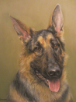
Fun Euchre Tournament
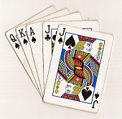
The German Shepherd Club of Rochester.
(Non-profit organization)
*Must be 21 or over to play. Please bring a friend or two to join the fun! *
Prizes will be awarded to the winner!
Refreshments/snacks included.
Sunday, November 8th
Registration fee: $20 per player.
Registration time: starts @ 12:30pm. Game starts @ 1 pm.
593 MOUNT HOPE AVE
ROCHESTER NY 14620-2743
R.S.V.P By: Sunday 11/1. (Limited seating available)
Email: colemanc@localnet.com
Or call Cynthia Paoli @ 585 406-9000
For more information about our club please visit our website: http://www.gsdcrocny.org/

